Week 7- Supplier Database

create database 1BM21CS113_Supplier;

use 1BM21CS113_Supplier;

create table Supplier

(

sid int primary key,

sname varchar(40),

city varchar(40)

);

create table Parts

(

pid int primary key,

pname varchar(30),

color varchar(30)

);

create table Catalog

(

sid int,

pid int,

primary key(sid,pid),

foreign key(sid) references Supplier(sid) on delete cascade on update cascade,

foreign key(pid) references Parts(pid) on delete cascade on update cascade

);

desc Supplier;

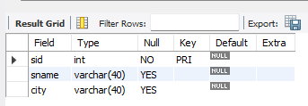

desc Parts;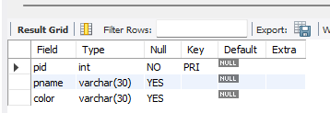

Alter table Catalog

add column cost decimal;

desc Catalog;

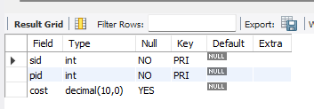

insert into Supplier values(10001,"Acme Widget","Banglore");

insert into Supplier values(10002,"Johns","Kolkata");

insert into Supplier values(10003,"Vimal","Mumbai");

insert into Supplier values(10004,"Reliance","Delhi");

select * from Supplier;

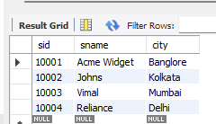

insert into Parts values(2001,"Book","Red");

insert into Parts values(2002,"Pen","Red");

insert into Parts values(2003,"Pencil","Green");

insert into Parts values(2004,"Mobile","Green");

insert into Parts values(2005,"Charger","Black");

select * from Parts;

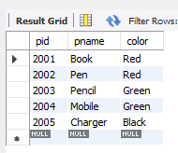

insert into Catalog values(10001,2001,10);

insert into Catalog values(10001,2002,10);

insert into Catalog values(10001,2003,30);

insert into Catalog values(10001,2004,10);

insert into Catalog values(10001,2005,10);

insert into Catalog values(10002,2001,10);

insert into Catalog values(10002,2002,20);

insert into Catalog values(10003,2003,30);

insert into Catalog values(10004,2003,40);

select * from Catalog;

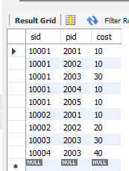

Week 7-Queries:

1. select distinct p.pname

from Parts p, Supplier s, Catalog c

where s.sid=c.sid and p.pid=c.pid;



2.select distinct s.sname

from Supplier s

where s.sid in(select sid

from Catalog

group by sid

having count(*)=(select count(*) from Parts));



3.select distinct s.sname

from Parts p, Supplier s, Catalog c

where s.sid=c.sid and p.pid=c.pid and p.color="Red";

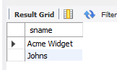

4.select distinct p.pname

from Parts p, Catalog c

where c.sid=(select sid from Supplier where sname="Acme Widget")

and p.pid=c.pid and c.pid not in(select c.pid

from Catalog c

where c.sid!=(select sid from Supplier where sname="Acme Widget"));

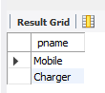

5.select c.sid

from Catalog c

where c.cost>(select avg(cost) from catalog c1 where c.pid=c1.pid);

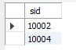

6.select s.sname

from Supplier s

where s.sid in(select c.sid from Catalog c where c.cost=(select max(cost)

from Catalog c1 where c.pid=c1.pid));

